**GIT HANDSON-5**

**Gitlab:** [**https://gitlab.com/thrinath852-group/gitdemo/-/tree/master?ref_type=heads**](https://gitlab.com/thrinath852-group/gitdemo/-/tree/master?ref_type=heads)

Explain how to clean up and push back to remote Git without symbols  
**Step 1:** Verify if master is in clean state  
**Step 2:** List out all available branches  
**Step 3:** Pull the remote git repository to the master  
**Step 4:** Push the pending changes to the remote repository  
**Step 5:** Observe if the changes are reflected in the remote repository

**Step 1:** Verify if master is in clean state

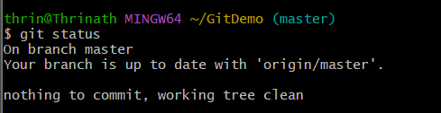  
  
**Step 2:** List all available branches

  
  
**Step 3:** Pull the latest changes from remote

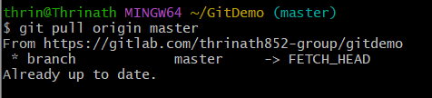  
  
**Step 4:** Push your local changes to remote



**Step 5:** Verify changes on remote

